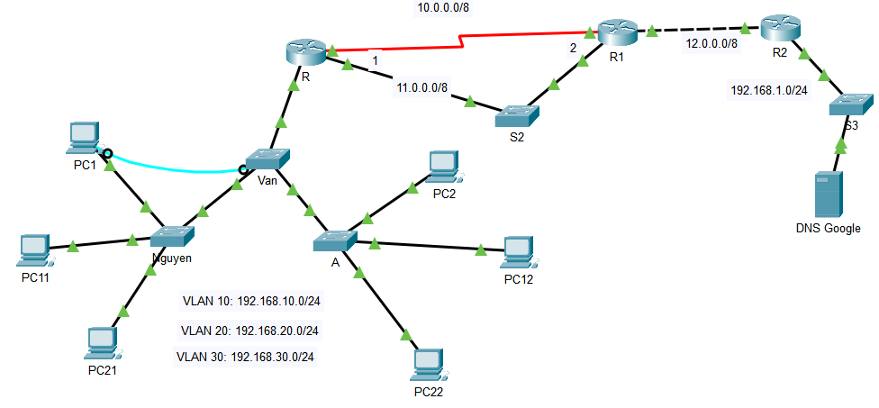

8.8.8.8

1. From the results of Lab 1.1, expand to the diagram as shown above (save file with name FullName_StaticRoute.pkt)

2. Configure ip address to the devices (ip address is shown in the picture)

3. Configure static route to ping between networks (in which the path from R -> R2: R->S2->R1 is the main route, R->R1 is the backup route)

4. Configure default route at R1 (go out network 12.0.0.0/8) and R2 (go out network 12.0.0.0/8)

5. Test ping from PCs in vlans to DSN google (8.8.8.8)

6. Shutdown interface g0/1 of R and check packets sent from any PC in vlans to 8.8. DSN google (8.8.8.8)

7. Save file with another file name (FullName_RipRoute.pkt and Configure RIP version 2 on router R, R1, R2

8. View routing table on routers (R, R1, R2)